Sunbeam House Services (SHS) take pride in supporting people with intellectual disabilities and complex needs to have choice and control over their lives. We offer a range of supports tailored to individual needs. We are a rights-based organisation and recognise that every person we support is unique and a valued member of society.

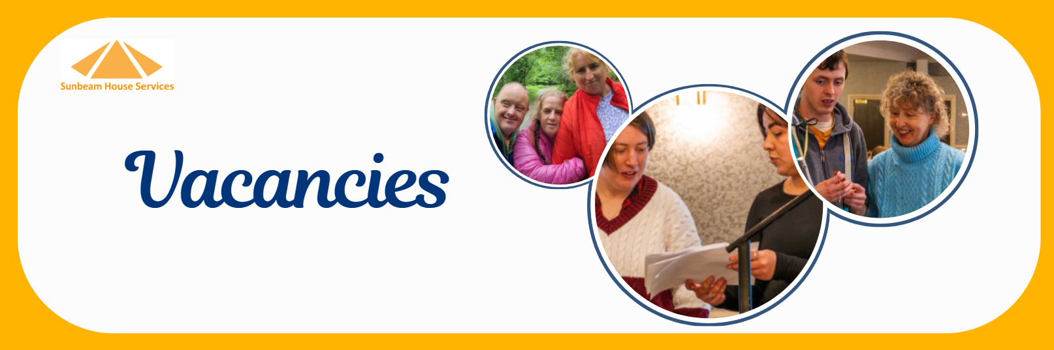

Speech & Language Therapist
Sunbeam House Services

Make a meaningful difference every day. Join Sunbeam House Services and support people with intellectual disabilities to communicate, connect, and thrive.

Why Join Us?
- Permanent, whole-time position
- HSE-aligned salary scale (€45,063 – €64,424 LSI)
- Supportive multidisciplinary team environment
- Strong focus on supervision, CPD and career development
- Values-driven organisation promoting dignity, respect and inclusion
- Based in Cedar Estate, Bray, Co. Wicklow

The Role
As a Staff Grade Speech & Language Therapist, you will work as part of a multidisciplinary team delivering high-quality, person-centred assessment and intervention services. You will collaborate with service users, families and colleagues to maximise communication, participation and quality of life.

What You Need
- Registration with, or eligibility for registration with, CORU
- Degree in Speech & Language Therapy
- Excellent communication and teamwork skills
- Commitment to evidence-based, person-centred practice
- Dysphagia qualification required for some posts
Ready to apply? Apply now and help us create brighter futures together: CV to talent@sunbeam.ie
Job Description:SHS _SLT_Basic_Job Description.docx

