 |   National Maternity Hospital .  Founded in 1894

Haemovigilance Officer

PERSON SPECIFICATION

&

JOB DESCRIPTION





National Maternity Hospital
About Us, Our Mission and Vision
The Hospital
The National Maternity Hospital is one of Europe’s largest maternity hospitals and a leading provider of maternity, women’s health and reproductive care, established over 130 years ago. Our expert multidisciplinary team is dedicated to providing the highest standard of care to women and their families, through a range of services including maternity, women’s health and neonatology. Over the years subspecialties have expanded to include expert, evidence-based care for women and babies incorporating fetal medicine, maternal medicine, anaesthetic care, perinatal genetics, perinatal mental health and bereavement care, pathology, radiology.

Our women’s health services have also expanded exponentially and our gynaecology team treats over 10,000 outpatients annually. Our colposcopy service is funded by the National Cancer Screening Service and has one of the largest units in Europe. We have also developed specialist services catering for urogynaecology, gynaecological cancer, complex menopause care, paediatric adolescent gynaecology, pain management, fertility and also transgender care.

The Neonatal Intensive Care Unit is recognised as a national tertiary referral centre for care of very premature babies and sick infants, with expertise in all advanced therapies such as neonatal therapeutic hypothermia. The hospital is also contributing to the National Neonatal Transfer Service which offers a national 24 hour service for the nineteen maternity units in Ireland.

The NMH established a community midwifery service in 1998, offering domino birth, early transfer home programmes and homebirth. This service covers Dublin and North Wicklow and continues to be the busiest community midwifery service in Ireland. Over the decades, the hospital has built up an international reputation for undergraduate and postgraduate training and education for the multidisciplinary team of healthcare providers in all related specialties. Staff are also able to avail of extensive professional development which is facilitated in association with our education providers including University College Dublin and the Royal College of Surgeons of Ireland.

Mission Statement
We are the national centre of clinical excellence in maternal, neonatal and gynaecological health. Our mission as leaders in women’s healthcare is to deliver the highest quality of safe, evidence based care. We are committed to providing choice, listening to and learning from our patients’ experiences. Through excellence and innovation in research and education, we drive the advancement of women and babies’ healthcare in Ireland. Our team is our greatest asset, and we are dedicated to investing in and supporting our people.
Vision
To continuously advance the health of women and babies through excellence in healthcare led by our dedicated teams.

VALUES; Quality, Compassion, Respect Collaboration, Innovation, Sustainability

“Delivering the future”

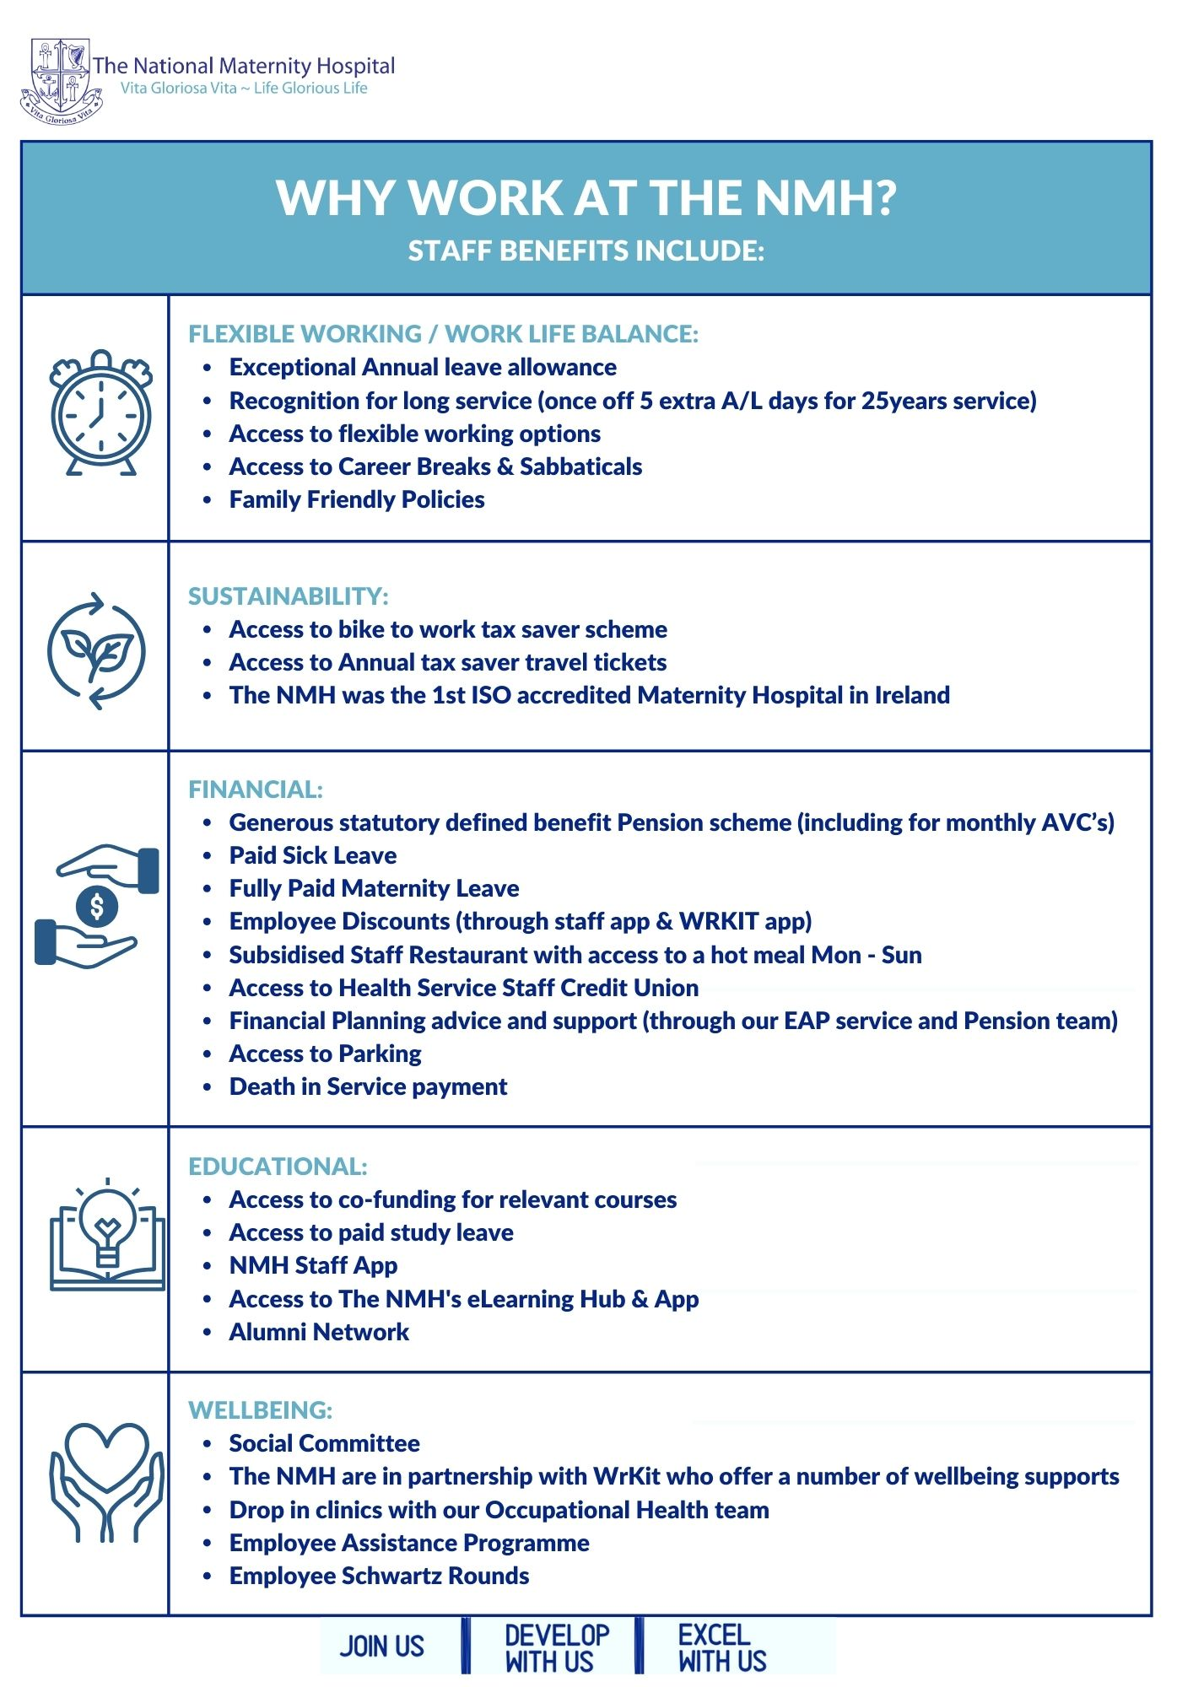

The Pathology and Laboratory Medicine Department
The Department of Pathology and Laboratory Medicine is committed to providing the best standard of care to the patients of the National Maternity Hospital. The department provides a comprehensive diagnostic laboratory service for women requiring antenatal, perinatal and gynaecological care including infertility assessment. The department also serves the needs of the neonatal intensive care unit.
The departmental organisational chart is depicted below
Convention for organisational chart:
1. Black lines indicate Direct reporting relationships and flow up the chart
2. Red Lines indicate Direct and Clinical reporting relationships and flow in the direction of the arrow
3. Green Lines indicate liaison relationships and flow in the direction of the arrow

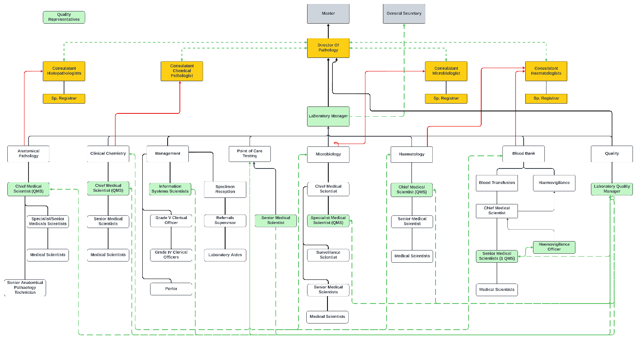

Job Specification / Terms and Conditions
Purpose of the Post: | To manage the haemovigilance function for the hospital, working with the Consultant Haematologist and Laboratory Manager, and to make sure the hospital meets national and international standards for safe transfusion practice. This covers promoting correct use of blood, full traceability of blood and blood components, monitoring and reporting adverse reactions and near misses, running education and training, and keeping transfusion policy and procedure documents current
Job Title: | Haemovigilance Officer
Grade: | Senior Medical Scientist
Department | Department of Pathology and Laboratory Medicine
Reports to | Chief Medical Scientist and Laboratory Manager
Responsible to | Consultant Haematologist and Laboratory Manager
Qualifications | Candidates must on the latest date for receipt of completed application forms hold the following minimum qualifications  • Be registered with the Nursing and Midwifery Board of Ireland in the General and/or Midwifery Division of the Register and to have name maintained on live register with the Nursing and Midwifery Board of Ireland and to have at least 5 years relevant nursing and/or midwifery experience.  OR  - Be registered with CORU– Regulating Health and Social Care Professionals on the Medical Scientists Register and maintain live annual registration and have a minimum of 4 years’ experience in a Blood Transfusion laboratory since qualifying as a Medical Scientist.  AND  - Working knowledge of the EU Blood Directive 2002/98/EC, SI 360 of 2005, and ISO 15189 accreditation  - Show evidence of continuing professional development  - Be of good character and in a state of health fit for the duties of the post
Terms & Conditions | Tenure: This is a Full Time permanent contract of employment.  Remuneration: Remuneration is in accordance with salary scales approved by the Department of Health/Health Service Executive. The salary scale for this post currently ranges from €68,687to €90,688 gross per annum (Grade Senior Medical Scientist, 3877). Assimilation onto the scale is based on relevant work experience and in accordance with circular 17/0213 for existing permanent employees. Payment is made on a monthly/fortnightly basis by credit transfer.  Hours:  Senior Medical Scientist: 35 hours per week, exclusive of unpaid rest breaks.  Annual Leave:  210 working hours per annum.  Superannuation/Spouses & Children’s Contributory Pension Schemes:  All employees must join the Superannuation Scheme. An explanatory booklet on the Superannuation Scheme you are aligned to is attached. If you require further details on the scheme please contact the Superannuation Officer, Human Resources on ext. 3360.  Retirement Age:  Persons who entered the Public Service before the 1st April 2004 must retire at the age of 65 years and are eligible for their pension entitlements from the age of 60 onwards. Persons who entered the Public Service on or after the 1st April 2004 will be eligible for their pension entitlements from the age of 65 onwards. Persons entering the Public Service from 1st January 2013, i.e. New Entrants, must retire at the age of 70 and are eligible for their pension entitlements from the age of 66 onwards.  Health:  A candidate for and any person holding the office must be fully competent and capable of undertaking the duties attached to the office and be in a state of health such as would indicate a reasonable prospect of ability to render regular and efficient service.  Garda Vetting:  Satisfactory Garda (Police) vetting is a condition of  employment for this position. It is expected, that you fully disclosed all  information pertaining to any convictions recorded against you in the  Republic of Ireland or elsewhere, or a statement of all convictions and/or  prosecutions, successful or not, pending or complete, in the State or  elsewhere as the case may be. Failure to do so will result in instant dismissal.
Responsibilities & Accountabilities  (in no particular order of priority) | Professional  - Comply with the CORU Code of Practice for Medical Scientists or the NMBI Code of Professional Conduct, whichever applies  - Maintain registration and keep up to date with continuing professional development  - Act in compliance with GDPR  - Ensure that policy in relation to the retention and control of quality and process records is followed.  - Participate on Pathology / external committees as required.  - Be innovative and open to change in striving to ensure the highest standards of service delivery  - Ensure that all service users are treated with dignity and respect and make certain that the welfare of the service user is a key consideration at all times  - Demonstrates a commitment to a quality service by monitoring and reviewing his/her own work and that of the team to ensure its quality and accuracy  Clinical Responsibilities  - Promote the correct use of blood and blood components, and identify ways to reduce wastage  - Make sure the hospital keeps full traceability of blood and blood components  - Monitor, investigate, and report serious adverse reactions, adverse events, near misses, and non-conformances to the Consultant Haematologist and Hospital Transfusion Committee  - Receive and record details of incidents, complaints, and defects, investigate as needed, and report findings to laboratory management.  - Report adverse events and transfusion reactions to the National Haemovigilance Office and Irish Blood Transfusion Service, as required  - Review and audit transfusion practice across wards and departments, and act on the results  - Carry out root cause analysis after adverse events and recommend corrective action  - Participate on the Hospital Transfusion Committee as an active member  - Act as part of a multi-disciplinary team and communicate information effectively while delivering the service  - Operate to the standards in the Quality Manual and support the ISO 15189 quality management system.  - Set and review haemovigilance KPIs on a regular basis  - Keep transfusion policy and procedure documents current  - Support the use of Blood Track or equivalent electronic blood management systems  Human Resource Management  - Plan, deliver, and evaluate haemovigilance education and training for all staff involved in transfusion  - Keep training records for all haemovigilance training given  - Facilitate professional development of staff involved in transfusion, through formal courses or informal on the job training  Health and Safety  - Participate in ensuring that effective safety procedures are in place to comply with the Safety, Health and Welfare at Work Act as within hospital policy.  - Assist and co-operate with laboratory Management Team in developing procedures to be followed in preventing and managing accidents occurring in the Laboratory area.  Quality  - The Department is accredited to ISO 15189.  - Operate to the standards laid down in the Quality Manual and associated procedures.  - Participate with initiatives involved in the implementation of the ISO 15189 quality management system.  - Actively participate in and monitor internal and external quality control and assurance programmes  - Ensure adherence to all codes of, and guidelines relating to, professional practice including the maintenance of Quality Assurance standards and accreditation.  - Ensure implementation of requirements of EU Directives and National Legislation on Blood Banking and adherence by all relevant laboratory staff to the policies and procedures  Information Technology  - Facilitate the collection, interpretation and presentation of data and information on Haemovigilance data according to the Hospital’s reporting needs.  Review  - Achievement of laboratory and personal objectives is facilitated by review.  - Participate in review process as outlined by the Laboratory Management team.  Any other duties deemed appropriate to the post. Please note that the duties of this post may change over time.
POLICIES AND PROCEEDURES: | For a full list of all the Hospitals Policies and Procedures please refer to Q-Pulse.  In particular, those as outlined within the Contract of Employment which you are required to familiarise and comply with, during the course of your employment.  Quality:  To ensure the provision of the highest possible quality of service to our patients, all employees at the National Maternity Hospital have a responsibility to ensure adherence to and participation in internal and external quality control and assurance programmes on an ongoing basis.  Healthcare Associated Infections (HCAIs):  In order to reduce the risk of HCAIs, compliance with Infection Prevention and Control policies and the attendance at infection control training, are essential for all staff members. It is paramount that each staff member practice good hand hygiene techniques. Staff members have a responsibility to report any obstacles to maintaining high standards of Infection Control and hand hygiene to their line manager or Infection Control Team  Reminder on Confidentiality:  In the course of his / her employment, the person appointed may have access to or hear information concerning the medical or personal affairs of patients or staff or other health service business. Such records or information are strictly confidential and unless acting on instructions of an authorised officer on no account must information be divulged or discussed except in the performance of normal duty. In addition records must never be left in such a manner that unauthorised persons can obtain access to them and must be kept in safe custody/destroyed in accordance with policy when no longer required.
Note: This job description is an outline of current broad areas of responsibility and accountability and should not be regarded as a comprehensive listing. As the role develops in the Hospital this job description may be reviewed in light of possible new structures and/or changing needs of the Hospital.

SENIOR MEDICAL SCIENTIST PERSON SPECIFICATION

- Statutory Registration, Professional Qualifications, Experience, etc.

(a) | Candidates for appointment must:
(i) | Be registered, or be eligible for registration, on the Medical Scientists Register maintained by the Medical Scientists Registration Board at CORU.
OR
(ii) | Applicants who satisfy the conditions set out in Section 91 of the Health and Social Care Professionals Act 2005, (see note 1 below*), must submit proof of application for registration with the Medical Scientists Registration Board at CORU. The acceptable proof is correspondence from the Medical Scientists Registration Board at CORU confirming their application for registration as a Section 91 applicant was received by the 30th March 2021.
AND
(iii) | Possess one of the following NFQ Level 9 post graduate qualifications or equivalent qualification at minimum Level 9 validated by the Academy of Clinical Science and Laboratory Medicine;  MSc Clinical Laboratory Science, Dublin Institute of Technology (DIT).  MSc Clinical Laboratory Science, Technological University Dublin (TU Dublin).  MSc Clinical Chemistry, University of Dublin, Trinity College (TCD).  MSc Biomedical Science, University of Ulster (UU)  MSc Biomedical Science, Cork Institute of Technology (CIT)/University College Cork (UCC).  MSc Biomedical Science, Munster Technological University (MTU)/University College Cork (UCC).  MSc Molecular Pathology, Dublin Institute of Technology (DIT)/University of Dublin, Trinity College (TCD).  MSc Medical Science, Atlantic Technological University (ATU)
OR
(iv) | An equivalent qualification at minimum Level 9 validated by the Academy of Clinical Science and Laboratory Medicine (ACSLM).
OR
(v) | Possess Fellowship of the Academy of Clinical Science and Laboratory Medicine awarded before July 2018.
OR
vi) |  | Have attained the Fellowship examination of the Institute of Biomedical Science (Awarded prior to 1999).
AND
(vii) |  | Possess four years full time clinical experience (or an aggregate of four years full time clinical experience) as a medical scientist in a clinical diagnostic laboratory since qualifying as a medical scientist.
AND
(viii) |  | Demonstrate evidence of Continuous Professional Development.
AND
(ix) |  | Have the requisite knowledge and ability (including a high standard of suitability and professional ability) for the proper discharge of the duties of the office.
AND
(x) |  | Provide proof of Statutory Registration on the Medical Scientists Register maintained by the Medical Scientists Registration Board at CORU before a contract of employment can be issued (Applicable to Section 38 applicants only).

- Annual registration* (Applicable to Section 38 Applicants only*)

(i) | On appointment practitioners must maintain annual registration on the Medical Scientists Register maintained by the Medical Registration Board at CORU
AND
(ii) | Practitioners must confirm annual registration with CORU to the HSE by way of the annual Patient Safety Assurance Certificate (PSAC).

- Health
Candidates for and any person holding the office must be fully competent and capable of undertaking the duties attached to the office and be in a state of health such as would indicate a reasonable prospect of ability to render regular and efficient service.
- Character
Candidates for and any person holding the office must be of good character.

Note 1*
Section 91 candidates are individuals who qualified before 31st March 2019 and have been engaged in the practice of the profession in the Republic of Ireland for a minimum of 2 years fulltime (or an aggregate of 2 years fulltime), between 31st March 2014 and 31st March 2019 are considered to be Section 91 applicants under the Health and Social Care Professionals Act 2005.
Note 2*
For information in relation to the type of applicants go to:
https://coru.ie/health-and-social-care-professionals/registration/what-kind-of-applicant-am-i-/

