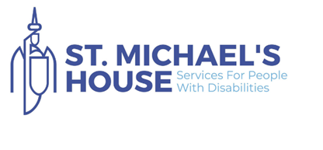

Information Booklet

St. Michael’s House
Social Care Worker – Emphasis on ASDS specific service delivery
Full-time and Part-time contracts available.

Location Glasnevin

OVERVIEW, VISION, AND ETHOS OF ST. MICHAEL’S HOUSE

St. Michael's House (SMH) is a leading organisation in the field of disability in Ireland and has a turnover of €100m; a staff complement of over 1,850 employees and delivers services to over 2,300 children and adults, their families, and carers in over 170 & networks locations across the greater Dublin area.

SMH has a research partnership with UCD and runs QQI accredited programmes of education up to and including Honours Degree Level through its Open Training College.

SMH provides the following comprehensive suite of services:

Children: Children’s Disability Network Services, Education Office, and Patron for 6 Special National Schools, CAMHSID Services, Preschool Support Services & Paediatric Medical Services.

Adult: Day Services, Local Centres, Vocational Centres, Training Centres, Supported Employment, Individualised Services, Community Support Services for the Older Persons, Mental Health, and Medical Services.

Respite: Formal Respite Services, Link, Community Respite, In-Home Support, Host Families, Fostering Services, and Individualised Respite.

Residential: Community Houses, High Dependency Nursing Houses, Alzheimer’s Centre, Independent Living, Challenging Behaviour, Individualised Residential Services.

Ancillary Services: Leisure Centre and Recreational Programme.

Adult Clinical Services: Psychiatry, Medical, Psychology, Social Work, Physiotherapy, Occupational Therapy, Speech and Language Therapy, Dietician, and Infection Control.

Through the Open Training College, the provision of a range of Accredited Programmes for staff up to Honours Third Level Programmes.

Research Programmes in Partnership with UCD.

Corporate/Administration Services: Human Resources, Finance, IT, Training and Development, Health and Safety, Fundraising, Transport, Maintenance Technical Services and Property Development, Safeguarding and HIQA communications.

St. Michael’s House is committed to offering services and supports that:
- Reflect the individual needs and choices of service users.
- Support individuals to develop meaningful relationships, to make a valued contribution and become active members of their community.
- Empower people to make choices about where they work, live, and socialise.
- Advocate for the improvement and development of services.
- Are cost-effective and accountable to service users, families, and funding authorities

- Vision:
- A society in which people of every ability can live the life of their choosing.

Mission:
- SMH works with Services Users to understand their needs and wishes and help them achieve their goals - “Your Life, Your Rights, Your Choices”

- Values:
Respect, Kindness, Honesty, Excellence, Creativity.

BOARDS OF ST MICHAEL’S HOUSE
  - St Michael’s House Group
  - St Michael’s House Service Board
  - St Michael’s House Properties
  - St Michael’s House Leisure Complex

DIRECT REPORTS TO CEO
- Director of Finance
- Director of Human Resources & Organisational Development
- Director of Quality Improvement and Safety Development
- Director of Support Services
- Director of Estates
- Director of Psychiatry
- Directors of Adult Services X 2
- Director of Nursing
- Director of Children’s and Young Person Services
- Director of OTC

- REGULATORY ORGANISATIONAL STRUCTURE – BOARD OF DIRECTORS

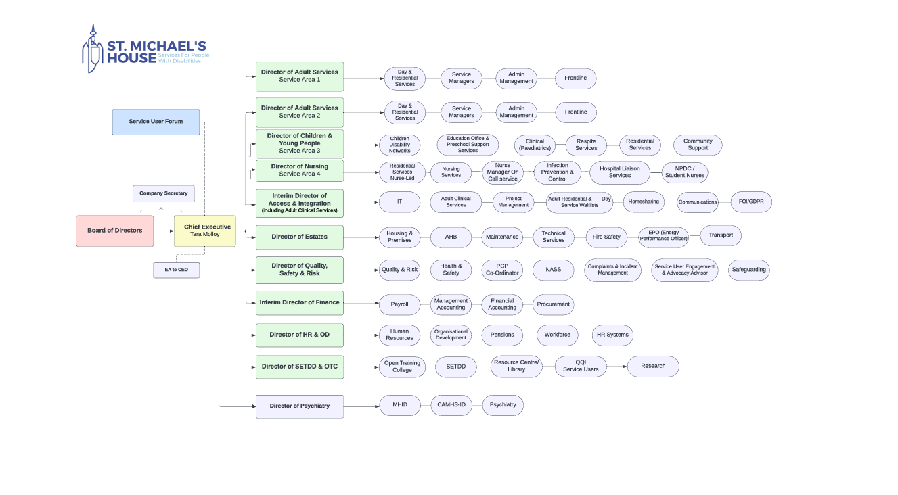

JOB DESCRIPTION AND PERSON SPECIFICATION

JOB TITLE AND GRADE | Social Care Worker
REPORTING RELATIONSHIP | The appointed candidate will report to Head of Unit.
SALARY SCALE | Successful candidates will be paid in line with June ‘26 HSE revised consolidated Social Care Worker pay scale point 1; €41,260 to point 14: €57,789 per annum based on working a 39-hour week.  New appointees to any grade start at the minimum point of the scale. Incremental credit will be applied for recognised relevant service in Ireland and abroad (Department of Health Circular 2/2011). Incremental credit is normally granted on appointment, in respect of previous experience in the Civil Service, Local Authorities, Health Service and other Public Service Bodies and Statutory Agencies.
ANNUAL LEAVE ENTITLEMENT | 24 days per annum pro rata based on hours worked.
HOURS OF WORK | 35 hours per week for Day Services (09:00 -16:00 – Mon – Fri).  Details of starting and finishing times, which may vary in accordance  with Service needs, will be notified to you by your Service Manager.  There will be times when you will be required to work outside of the  normal office hours.
LOCATION | St. Michael’s House provides services in four service areas, three for adults and one for children and young persons. You will initially be assigned to Swords, Finglas, Templeogue, Balbriggan, Baldoyle, Ballymun, Edenmore, Goatstown.
CONTRACT TYPE | Permanent

About Role:

St. Michael’s House are recruiting a Social Care Worker for a community day service for adults with intellectual disability and autism. The provision of high quality, person centred, service provision that is specific to people who present with Autism, have an associated ID and who require high levels of support.
St. Michael's House is a community-based organisation committed to providing a quality person
centred service and high standard of living to people with an intellectual disability in the greater
Dublin area.

The successful candidate will have the opportunity to work with a skilled and responsive staff team
to deliver a high-quality service. Working closely with the Social Care Leader, multi-disciplinary team
and families, the key task is to provide positive behaviour and person centred supports to ensure a
good quality of life for our people.
DUTIES AND RESPONSIBILITIES:
Key duties associated with the role:
- Support each person to effectively communicate and to ensure they make informed decisions, exercise choice, control and autonomy in their life.
- Contribute to and monitor outcomes for the person as identified in the personal planning processes.
- Identify supports and work in partnership with the individual, their family and other supports as outlined within individual plans.
- Have an understanding of creating appropriate Autism specific environments and be aware of and able to work with Positive Behavioural Support Plans.
- Delivering a quality service and ensuring professional standards are maintained in accordance with national and local requirements.
- Work within current legislation and policies, procedures, guidelines and protocols as laid down by the employer and support staff to ensure they are aware and adhere to same.
- Initiating, maintaining and co-ordinating care, training, treatment and education programmes for all attendees in Solas.
- To promote self-development, independence and individuality of the attendee placing an emphasis on enhancing opportunities and development relating to vocational, recreational and employment needs.
- Work closely with and report to the Service Manager, escalating appropriate issues and managing and finding solutions to issues.
- Assist front line staff members in the design implementation and evaluation of Person Centred Plans (PCPs) for people who attend the service.
- Promote the rights of each person within the service and create a human rights based culture within the service.
- Chair and participate in staff meetings and cluster meetings.
- Attend and participate in Case Reviews (ICMS) or any other meeting required to assess needs as requested by Service Manager, Director of Services or other clinical or operational staffing.
- The immediate reporting of any safeguarding or behaviours of concern through the appropriate organisational channels.
- Provide written and verbal reports on a regular basis on the progress and development of people who use the service.
- Provide leadership and motivation that is conducive to good staff relations and effective work performance
- Co-operate with external monitoring and statutory inspections and implement their recommendations.
- Manage develop and support staff individually and as a team, including induction, probation, supervisory support and training.
- Liase with parents and families as required
- Be responsible for budgets within the support centre
- Ensure Annual Leave is planned in accordance with local and organisational policies
- Full clean drivers licence as a driver is essential.
CONFIDENTIALITY:
The post holder will have access to various types of records/information in the course of work.
Such records and information are strictly confidential and unless acting on the instruction Of
an authorised person, on no account must information concerning staff, service users or other
service business be divulged or discussed except in the performance of normal duty. In
addition, records may never be left in such a manner that unauthorised persons can obtain
access to them and must be kept in safe custody when no longer required.

The post holder may be required to perform other duties as appropriate to the post, which may be assigned to him/her from time to time, and to contribute to the development of the post while in office. This job description will be subject to review in the light of changing circumstances. It is not intended to be exhaustive but should be regarded as providing guidelines within which individuals work.

Factors | Essential | Desirable
Qualifications | QQI Level 7 Bachelor of Arts in Applied Social Studies (Disability) - Open Training College; | Additional Autism specific training
 | Bachelor of Arts (Honours) in Social Care Practice | Positive Behavioural Support Training
 | Bachelor of Arts (Honours) in Applied Social Care
Level 7 award in Social Care/Studies delivered by
an Institute of Technology, DIT or National
University of Ireland.
A qualification received outside the State
recognised by NARIC as equivalent to the Irish
Level 7 award
And/or be in the process of being CORU
registered or fully registered as a Social Care
Worker
Experience | Must have prior experience of working directly with people who present with an autism diagnosis. | Experiencing in rolling out interventions in relation to communication supports.
 | Have experience of supporting behaviours that challenge and an ability to work within the constraints of clinically led support plan. | Experience in creating and working with individuals to produce weekly/monthly timetables.
 | Be creative, innovative and be open to working on interventions in new ways. | Have a knowledge of working with New Directions.
 | Previous experience of supporting individuals  with intellectual disability. | Have experiencing in working with different community stakeholders to open up vocational, recreational and educational opportunities to the people they support.
 | Have experience of working as part of a team.
Experience implementing positive behaviour
support plans.
 | Excellent communication skills.
 | Eligible to work in Ireland.
 | - Full driving licence or in the process of gaining same and be willing to drive as part of your role

- CORE COMPETENCIES
Quality Service
- Adopts a person-centred approach and supports service users with empathy, compassion, and respect.
- Demonstrates a commitment to achieving a high standard result.
- Is flexible and adaptable to meet unanticipated demands.
- Complies with organisational policies and procedures at all times.
- Understands, demonstrates, and respects the rights of all service users and families
- Has an understanding of Autism specific principles.

Planning & Organising
- Demonstrates the ability to plan and deliver the duties of the role in an effective and resourceful manner within a model of person-centred care.
- Adopts a systematic approach to planning, organising, and managing workload.
- Able to multitask without losing focus.
- Manages competing and changing priorities effectively.
- Demonstrates a flexible and adaptable approach in a changing environment.
- Deals with issues in a timely manner.
- Demonstrates a high level of attention to detail.

Professionalism
- Approaches all tasks in a confident manner.
- Shows pride in one’s profession.
- Demonstrates honesty and integrity and holds a strong code of ethics.
- Maintains appropriate and professional boundaries.
- Manages personal problems to minimise impact on work or professional relationships.
- Respects confidentiality and discretion in all work-related matters.
- Pays attention to dress code and professional appearance.
- Shows an enthusiastic and committed attitude to one’s work.
- Understands scope of practice.
- Understands the need to apply service and/or professional standards, policies and procedures
- Demonstrates self-belief in own potential and ability.

Continuous Learning & Development
- Shows enthusiasm and motivation for work.
- Willing to use opportunities to improve, learn and develop self.
- Regularly participates in on-the-job learning.
- Stays current in own field of expertise.
- Is open to constructive feedback, acknowledges own limitations.
- Understands role and boundaries of other disciplines.
- Initiates and undertakes mandatory training.
- Takes responsibility to ensure learning and understanding of new ideas and procedures.
- Self-evaluates own performance to continuously improve personal development.

Organisational Knowledge
- Understands the mission and core values of St. Michael’s House
- Is aware of the multiple services provided by St. Michael’s House
- Familiar with professional bodies.
- Is knowledgeable of regulations and where relevant applies practice in accordance with legislation to area of work.
- Has the skill set to access computer systems and ability to learn new IT systems?
- Knowledgeable of professional standards, policies, and procedures relevant to discipline.
- Understands how own scope of practice fits with the organisation.

Innovation & Creative Thinking
- Generates new ideas.
- Shows enthusiasm for trying new ways of doing things.
- Takes a creative approach to work by exploring a range of options and trying new ideas whilst keeping an open mind.

Leadership Potential
- Successfully modifies behaviour to embrace change.
- Energetic and Inspires others through own positive attitude.
- Creates trust by being honest, reliable, and consistent.
- Can be directive without being dictatorial.
- Blends a focus on results with a caring and sensitivity for individuals.
- Demonstrates the ability to be flexible in relation to hours of work and roles and responsibilities.
- Responds positively to new demands and requirements.

Problem Solving & Decision Making
- Makes timely, intuitive decisions to achieve successful outcome.
- Identifies and uses appropriate sources of information when making decisions.
- Supports views with sound logic reasoning.
- Reasons systematically and logically through issues.
- Demonstrates common sense when dealing with everyday issues that arise.
- Knows when to ask for help and guidance from supervisor and/or colleagues

Teamwork
- Contributes consistently and positively to team activities.
- Projects a warm and appropriate professional demeanour at all times.
- Is accepting of diverse values and beliefs.
- Helps others: willing to take on different tasks/roles accordingly to the needs of the team.
- Expresses views and professional opinion at team meetings.
- Knows when and where to consult with other members of the team.
- Is responsive to the needs of other team members shows empathy.
- Balances listening to others’ ideas with sharing own thoughts.
- Considers how one’s behaviour may impact others.
- Has the knowledge and confidence to identify and personally manage own workplace disagreements locally at an early stage and knows when to seek support of management.

Communication & Interpersonal Skills
- Communicates openly and honestly.
- Shows empathy when handling delicate or sensitive issues, shows patience when dealing with others.
- Considers how one’s behaviour may impact others.
- Clearly and confidently articulates ideas and opinions and their underlying rationale.
- Draws on a variety of communication methods to fit/situation circumstances.
- Open listening: asking clarifying questions and makes eye contact.
- Demonstrates positive body language.
- Communicates effectively in English language, written and spoken, as appropriate to job requirements.

- TERMS AND CONDITIONS
Garda Vetting:
St. Michael’s House recognise its responsibilities under the National Vetting Bureau (Children and Vulnerable Persons) Act 2012-2016.This act applies to those employees who provide care for children and vulnerable adults. St Michael’s appointed liaison person will apply for vetting disclosure for new and current employees.

Probation:
Every appointment of a person shall be subject to a probationary period of 6 months. St. Michael’s House reserves the right to extend the probationary period.

Superannuation:
This is a pensionable position. The successful candidate will upon appointment become a member of the appropriate pension scheme. Pension scheme membership will be notified within the contract of employment.
Public servants joining the public service or re-joining the public service with a 26 week break in service, between 1 April 2004 and 31 December 2012 (new entrants) have no compulsory retirement age.
Public servants, joining the public service or re-joining the public service after a 26-week break, after 1 January 2013 are members of the Single Pension Scheme and have a compulsory retirement age of 70.
Applicants will be required to declare whether they have previously availed of a Public Service
scheme of incentivised early retirement. Applicants will also be required to declare any entitlements
to a Public Service pension benefit (in payment or preserved) from any other Public Service employment and/or where they have received a payment-in-lieu in respect of service in any Public
Service employment.

Age:
The Public Service Superannuation (Age of Retirement) Act, 2018 (Public Servants not affected by this legislation) set 70 years as the compulsory retirement age for public servants.

Health:
A candidate for and any person holding the office must be free from any health-related issue which
would render him/her unsuitable to hold the office and be in a state of health as would indicate a
reasonable prospect of ability to attend regular and efficient service.

Character:
A candidate for and any person holding the office must be of good character.

Ethical Code:
The post holder is requested to respect the special charisma, ethos, and tradition of St Michaels House and to observe and comply with its general policies, procedures, and regulations.

Mobility:
The movement of employees between locations is an essential component of St. Michael's House's strategy to ensure the appropriate and equitable allocation of human resources, skills, and experience. This mobility is a necessary requirement to meet the service requirements of this position effectively.

- SELECTION PROCESS

How to Apply:
All of the below documents must be submitted before the application is deemed complete:
- A comprehensive CV, detailing education, skills, career history, experience.
- A short cover letter/personal statement outlining why you wish to be considered for the post and where you believe your skills, experience and values meet the requirements of the position of Social Care Worker within St. Michael’s House.

Closing Date: 20th October 2026 @ 5pm
Shortlisting will happen and candidates who meet criteria will then be notified of an interview date.

Please note, only shortlisted candidates will be contacted.

Informal enquires:
Informal enquiries can be made to – sinead.kavanagh@smh.ie 0872344981
Selection Process:
The Selection Process may include: -
- Shortlisting of candidates, based on the information contained in their application and assessment of competencies detailed in respect of the role.
- In-Person Interview: A face-to-face meeting to assess suitability for the position.
- A secondary interview to further explore qualifications or clarify any outstanding questions.

Please Note:
- You can expect to receive emails from us at the relevant stages notifying you to check your email for campaign updates.
- We endeavour to give as much notice as possible for interview dates etc. Candidates should make themselves available on the date(s) specified by St. Michael’s House.

References:
It is the policy of St Michael’s House to collect three references from your last three employers and they must be from the Manager you reported to.

Please be assured that we will only collect the details and contact referees should you come under consideration and with your agreement.
Other Information

Confidentiality:
Subject to the provisions of the Freedom of Information Act, 2014 applications will be treated in strict confidence. All enquires, applications and all aspects of the proceedings are treated as strictly confidential and are not disclosed to anyone, outside those directly involved in that aspect of the process. Certain items of information, not specific to any individual, are extracted from computer records for general statistical purposes.

Deeming of candidature to be withdrawn:
Candidates who do not attend for interview when and where required by St. Michael’s House or who do not, when requested, furnish such evidence as is required regarding any matter relevant to their candidature, will have no further claim to consideration.

GDPR:
When your application form is received, we create a record in your name, which contains much of the personal information you have supplied. This personal record is used solely in processing your candidature and should you be successful certain information you provide will be maintained on file.

Retention period for data collected:
For candidates who were unsuccessful in the recruitment process, their cover letter, CV, and interview notes will be retained for 12 months. For successful candidates, their cover letter, CV, and interview notes will be placed on their employee file and retained during their employment.

Such information held is subject to the rights and obligations set out under GDPR. To make a request under GDPR please submit your request in writing to:

The Data Protection Officer, St. Michael’s House, Ballymun Road, Dublin 9.

Candidates should note that canvassing will disqualify.
St. Michael’s House is an Equal Opportunities Employer.

