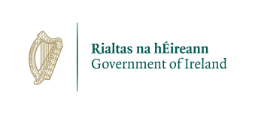

Candidate Information Booklet

Intern, Political Division,
Department of Foreign Affairs and Trade

Location: Dublin 2

Department: Foreign Affairs and Trade

Closing Date: 12 noon, Thursday 8 October 2026

Email
WEBSITE

TABLE OF CONTENTS

1. ABOUT THE CIVIL SERVICE 2
2. ABOUT THE DEPARTMENT 3
3. ABOUT THE ROLE 3
4. LOCATION 4
5. WHO WE ARE LOOKING FOR 4
6. WHAT WE OFFER 4
7. THINGS YOU NEED TO KNOW 5
7.1 Eligibility 5
7.2 Selection Process 6
7.2.1 How to Apply 6
7.2.2 Selection Process 6
7.2.3 Right to Review 7
7.2.4 Department’s Application, Selection and Right to Review Process 7
7.3 Working for the Civil Service 7
7.4 Data Protection Policy 7
7.5 Accessibility, Disability and Reasonable Accommodation for the Selection Process 8
Appendix A: Flexible and Family Friendly Policies 9
Appendix B: DFAT Intern Capability Framework 10
Appendix C: Appeals Process Outline 13

ABOUT THE CIVIL SERVICE
The Civil Service is at the heart of Irish society. Everything we do impacts our country and our people. We are a robust and trusted institution, which has served the people of Ireland since the foundation of the State. Civil servants and Civil Service organisations play a crucial role in providing and supporting the delivery of necessary front-line services to help meet the needs of our people and implement government policy. Our experience dealing with national and international issues has shown the tremendous commitment, resilience and ability of the Civil Service to respond with innovation and determination to any challenge.
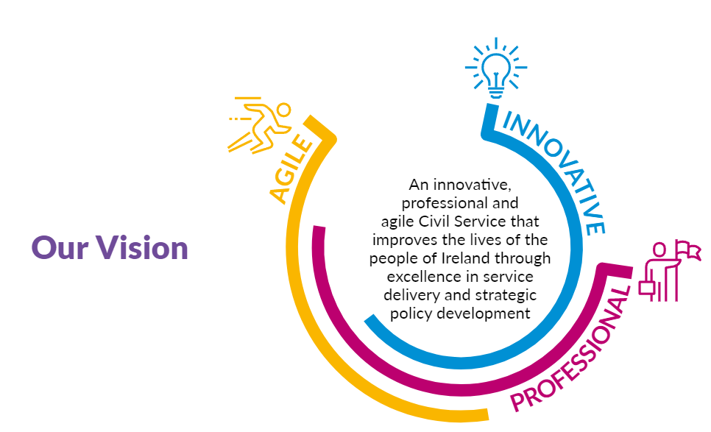
Climate change and sustainability, geopolitical and demographic changes, housing and healthcare add complexity to the environment in which the Civil Service operates. We therefore need agile and resilient staff to support the Government in managing the breadth of complex issues and in preparing for the future.
While the challenges which face the Civil Service today are different to those faced at the foundation of the State, our core values remain the same.
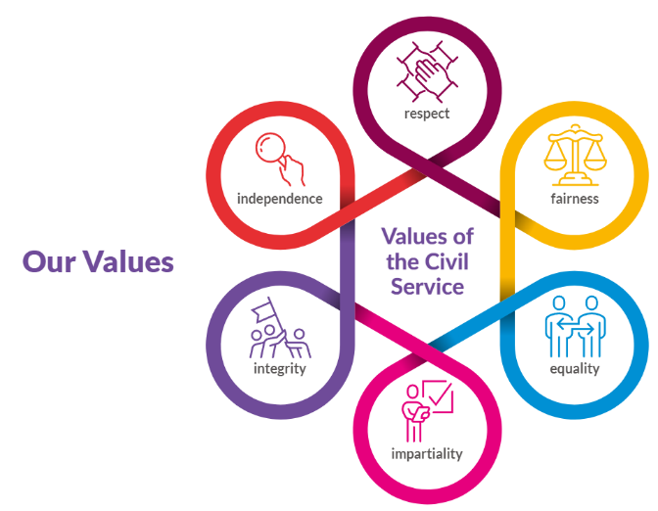
The Irish Civil Service employs people in over 40 Government Departments and Offices with a diverse set of responsibilities. We support the Government by developing policy options and legislation to address major national issues, co-ordinating the broader public service, helping to manage the economy and delivering services to the public.
Civil Service Renewal 2030 is an ambitious 10-year strategy of reform for the Civil Service. Aligned to it, Better Public Services, the Public Service Transformation Strategy, aims to deliver for the public and build trust. Together, both programmes aim to deliver a diverse and high performing Civil Service that is more inclusive, engaged and agile. By implementing these plans and demonstrating an enduring commitment to public service values, the Civil Service can create a more diverse yet unified, professional, responsive, open and accountable organisation that inspires confidence in Ireland and internationally.
The Civil Service can offer suitable candidates a very satisfying and varied career, with competitive terms and conditions. All civil service employers are committed to championing an inclusive and diverse workforce that reflects modern Ireland and the people we serve. We strive to create a culture where all staff have equal access to opportunity and feel comfortable and empowered to be themselves at work.

ABOUT THE DEPARTMENT
The mission of the Department of Foreign Affairs and Trade is to serve Ireland, promote our values and interests abroad, and to provide the Government with the capabilities and influence to ensure that Ireland derives the maximum benefit from all areas of its external engagement. Further information about the Department’s priorities and goals can be found in the Department’s Statement of Strategy 2025-2028.
The Statement of Strategy focuses on commitments in the programme for government and current international challenges. It notes six high-level goals which guide the work of the Department as follows:
- Support peace and reconciliation at home;
- Serve our citizens and strengthen our communities abroad;
- Lead and shape the European agenda;
- Respond to a changing geopolitical context;
- Deepen our global engagement and drive our trade and prosperity; and,
- Build our capacity to innovate and deliver.
The Department provides advice and support to the Minister for Foreign Affairs and Trade, the Ministers of State assigned to the Department, and the government on all aspects of foreign policy including international development and Ireland’s international development programme, known as Irish Aid.
With over 3,500 staff serving in over 100 locations worldwide, the Department of Foreign Affairs and Trade attaches the highest priority to ensuring equality, diversity and inclusion in its workforce and in its policies as it strives to be an organisation that reflects the diversity of the people it serves.
Detailed information about the work of the Department of Foreign Affairs and Trade is available on www.gov.ie/dfat.

ABOUT THE ROLE
The Political Division is staffed by a range of Units who cover a spectrum of thematic, multilateral and bilateral issues, including security and defence policy, UN issues, non-proliferation and disarmament matters, human rights, and conflict resolution, as well as Ireland’s relations with the Middle East, and Central Asia, the Caucasus and Eastern Europe.

The Political Division is responsible for ensuring that Ireland’s values, interests and foreign policy objectives are reflected in the EU’s Common Foreign and Security Policy (CFSP) and the EU’s Common Security and Defence Policy (CSDP). The Division also works to ensure that Ireland’s positions are advanced in various multilateral fora, most notably within the United Nations system, reflecting Ireland’s support for effective multilateralism and a stable rules-based international order.

Internships in the Political Division of the Department of Foreign Affairs and Trade are designed to provide the successful candidate with the opportunity to gain practical experience in policy development and in a particular area of work of the Department of Foreign Affairs and Trade. Internships will be for a duration of 22 months.

The pay rate applicable will be €38,803 p/a rising to €40,764 p/a after 12 months in the role. There is no entitlement to Civil Service status.

The Department of Foreign Affairs and Trade is committed to a policy of equal opportunity.

Job Specification:
Interns in Political Division work on a variety of tasks and projects, including:
- Drafting of briefing papers and reports on selected issues
- Attending and taking notes at meetings
- Preparing material for public communications
- Responding to public queries and requests for information
- Research and policy analysis
- Contributing to the design, planning and smooth running of conferences, visits and events
- Other duties to support the ongoing work of their Unit as required

Please note that the above list of responsibilities is not exhaustive.

LOCATION
If you are successful in this competition, you will be placed on a panel in order of merit. As vacancies arise, candidates will be drawn from the panel in order. Internships will be based in the Department of Foreign Affairs and Trade, Bishop's Square, Redmond's Hill, Dublin 2. Successful candidates may, on occasion, be offered a role in other divisions of the Department.

This panel will expire two years after it is formed.

WHO WE ARE LOOKING FOR

The person we are looking for will meet the following essential requirements by the closing date of this competition.

Essential requirements:

- A first or second class primary honours degree (at level 8 on the National Framework of Qualifications).
- High level of oral and written communication skills, including excellent applied writing skills.
- A strong interest in Irish and EU foreign and security policy (Common Foreign Security Policy and Common Security and Defence Policy).
- Excellent interpersonal skills, initiative and good judgement.
- Good administrative, organisational and computer skills.
- Flexibility and capability to work both independently and as a member of a team.

Desirable Requirements

- An undergraduate degree in a relevant discipline, including but not limited to, Politics, Law, History, Area Studies, European Studies, Economics, International Relations, and Human Rights.
- A postgraduate degree in a relevant discipline.
- Work experience of at least 12 months' cumulative duration and preferably in a relevant field.
- Familiarity with social media and communications strategies.

Key Capabilities

Candidates must also be able to demonstrate the capabilities identified as being important for intern roles as set out in detail in Appendix B. These capabilities are as follows:
- Building Future Readiness;
- Evidence Informed Delivery;
- Leading & Empowering;
- Communicating & Collaborating.

WHAT WE OFFER

- A temporary position on a fixed term contract in the Political Division of the Department of Foreign Affairs and Trade.
- A competitive salary. The pay rate applicable will be €38,803 p/a rising to €40,764 p/a after 12 months in the role. There is no entitlement to Civil Service status.
- Annual Leave: 23 days
- Hours of Attendance: 41 hours and 15 minutes gross per week

Important Note
Entry will be at the minimum of the pay scale, and the rate of remuneration will not be subject to negotiation and may be adjusted from time to time in line with Government pay policy.
Different terms and conditions may apply if you are a currently serving civil or public servant.
All offers are for immediate appointment.
In applying for this competition you accept that, if offered a post, you will be able to commence duties within a reasonable timeframe. Start dates are determined by business needs, and appointees will be expected to take up duty within this period once an offer is made. Requests for deferral will only be considered in exceptional circumstances and remain entirely at the discretion of the Department.
.

THINGS YOU NEED TO KNOW

7.1 Eligibility

Eligibility:
Eligible candidates must be:
- A citizen of Ireland;
- A citizen of the European Economic Area (EEA). The EEA consists of the Member States of the European Union, Iceland, Liechtenstein and Norway; or
- A citizen of the United Kingdom (UK); or
- A citizen of Switzerland pursuant to the agreement between the EU and Switzerland on the free movement of persons; or
- A non-EEA citizen who has a stamp 4 permission¹ or a Stamp 5 permission.

¹ Please note that a 50 TEU permission, which is a replacement for Stamp 4EUFAM after Brexit, is acceptable as a Stamp 4 equivalent.

Candidates who have previously undertaken an internship of six months or more in the Department of Foreign Affairs and Trade or in an Irish diplomatic mission abroad are not eligible to compete. Successful applicants will also be ineligible for any future intern positions which may arise in other areas of the Department.

Please note: due to the restricted nature of the work, the internship with the Disarmament and Non-Proliferation Unit is open to Irish citizens only.

Fulfil Health & Character, Garda Vetting and Security Clearance and Reference Check requirements and meet the criteria regarding Public and Civil Service Redundancy/Ill Health Retirement Schemes (CLICK HERE for further information).

It is important that you list any previous civil or public service employment, if you have availed of a voluntary redundancy or retirement scheme and/or are in receipt of an ill-health retirement pension. Failure to do so could lead to disciplinary action.
IRISH PROFICIENCY
As part of our ongoing commitment to support the Irish language, our leadership on the Gaeilge365programme and to comply with the Official Languages (Amendment) Act 2021, we are gathering information on candidates’ capacity to speak Irish.
Under this legislation, public bodies are required to ensure that 20% of new recruits can perform their duties through Irish by 2030. While this position is not an Irish language speaking role, we will be asking all successful candidates to indicate their current level of Irish language ability.
This information will be used for workforce planning purposes only.

PLEASE NOTE
Qualifications/eligibility may not be verified until the final stage of the process. Therefore, those candidates who have not met the specified eligibility requirements and proceed with their application are putting themselves through unnecessary effort/expense and will not be offered a position from this campaign. An invitation to tests, interview or any element of the selection process is not acceptance of eligibility.

7.2 Selection Process

7.2.1 How to Apply

Applications should be made on the online application form via the Rezoomo platform. Further information including details on how to apply can be found here.

Please note: if you do not already have an account on the Rezoomo platform you will be required to create one in order to apply.

All applications will be acknowledged. If you do not receive an acknowledgment within three working days after the closing date of the competition, please contact the Department’s Competitions Team.

All queries should be submitted in writing in the first instance to competitions@dfa.ie.

The closing date for completed applications is 12 noon on Thursday 8 October 2026.

7.2.2 Selection Process
The selection process for this role may include the following stages:
- Shortlisting based on the information provided by candidates in their application form;
- Written Test; and,
- Interview.

Admission to the competition:
The admission of a person to a competition, or invitation to attend interview, or a successful result letter, is not to be taken as implying that the Department is satisfied that such a person fulfils the requirements.

Non-Refund of Expenses:
Any expenses incurred by candidates whilst undertaking or attending any elements of the selection process will not be refunded.

Candidates deemed to be withdrawn:
Candidates who do not attend for interview, or who not, when requested, furnish such evidence as the Department may require in regard to their candidature, will have no further claim to consideration.

Candidates' Obligations

Candidates must not:
- knowingly or recklessly provide false information
- canvass any person with or without inducements
- personate a candidate at any stage of the process
- interfere with or compromise the process in any way

Any person who contravenes the above provisions or who assists another person in contravening the above provisions is guilty of an offence. A person who is found guilty of an offence is liable to a fine/or imprisonment.

In addition, where a person found guilty of an offence was or is a candidate at a recruitment process, then:

- where he/she has not been appointed to a post, he/she will be disqualified as a candidate; &
- where he/she has been appointed subsequently to the recruitment process in question, he/she shall forfeit that appointment.

Canvassing
Candidates should note that canvassing will disqualify and will result in their exclusion from the process

7.2.3 Right to Review

This selection process will be conducted in accordance with the Code of Practice for Appointment to Positions in the Civil and Public Service (2022) published by the Commission for Public Service Appointments.

The Code reflects the following core principles:
- Probity
- Merit
- Best Practice
- Consistency
- Transparency
- Appointments promoting equality, diversity and inclusion

Candidates are advised to familiarise themselves with the contents of the Code of Practice including, inter alia, the provisions in relation to the responsibilities placed on candidates.

Complaints and Requests for Review
Complaints/requests for review will be considered by Human Resources in accordance with the procedures set out in the Code of Practice. The Code of Practice may be accessed by visiting www.cpsa.ie or by contacting the Commission.

7.2.4 Department’s Application, Selection and Right to Review Process

An outline of the review process is included as Appendix C.

7.3 Working for the Civil Service
Interns are temporary Civil Servants subject to the same rules and regulations as any permanent Civil Servant. The Civil Service Code of Standards and Behaviour sets out the standards of behaviour expected of Civil Servants. If successful in this competition you must behave according to the code’s principles and live by its values.

The Civil Service embraces diversity and is an equal-opportunities employer. We are committed to championing an inclusive and diverse workforce that reflects modern Ireland and the people we serve. We strive to create a culture where all staff have equal access to opportunities and feel comfortable being themselves.

The Department will run this competition in compliance with the Code of Practice for Appointment to Positions in the Civil Service and Public Service, prepared by the Commission for Public Service Appointments (CPSA).

7.4 Data Protection Policy
The General Data Protection Regulation (GDPR) came into force on the 25 May 2018, replacing the existing data protection framework under the EU Data Protection Directive. Information submitted with this job application is used in processing your application. All applications are treated with the strictest of confidentiality and all necessary precautions will be taken to ensure the security of your data.

7.5 Accessibility, Disability and Reasonable Accommodation for the Selection Process

We are committed to promoting equality of opportunity and to ensuring that our recruitment processes are accessible and inclusive for all candidates.
If you have a disability or if you think you may require a reasonable accommodation at any stage of the selection process, we strongly encourage you to make this known at the earliest opportunity so we can ensure you get the support you need. Such accommodations may include adjustments to the format or delivery of assessments, additional time, or other tailored supports.
All requests for reasonable accommodations will be considered on a case-by-case basis, having regard to the individual circumstances, in line with best practice and current legislation. Having a disability or requiring adjustments will not impact your progress in the selection process, and you will not be disadvantaged by disclosing your disability or requirements. All information provided in this context will be treated as strictly confidential.
Candidates who wish to discuss or request a reasonable accommodation should:
- Indicate this on their application form, or
- Contact the recruitment team at competitions@dfa.ie as early as possible.
Candidates should provide sufficient detail regarding the nature of the accommodation required to assist in making appropriate arrangements. Where necessary, we may seek supporting medical or professional documentation to facilitate the assessment of the request.
We are committed to engaging with candidates to ensure, insofar as practicable, that appropriate supports are put in place to enable equitable participation in the recruitment process for all candidates.

Secrecy, Confidentiality and Standards of Behaviour - Official Secrecy and Integrity
During the term of the probationary contract, an officer will be subject to the Provisions of the Official Secrets Act, 1963, as amended by the Freedom of Information Act 2014. The officer will agree not to disclose to unauthorised third parties any confidential information either during or subsequent to the period of employment.
Civil Service Code of Standards and Behaviour
The appointee will be subject to the Civil Service Code of Standards and Behaviour.
Ethics in Public Office Acts
The Ethics in Public Office Acts will apply, where appropriate, to this appointment.
Political Activity
During the term of employment the officer will be subject to the rules governing public servants and politics.
All circulars are available on the website www.circulars.gov.ie or from the Personnel Section.
Important Notice
The foregoing represents the principal conditions of service and is not intended to be the comprehensive list of all terms and conditions of employment which will be set out in the probationary contract to be agreed with the successful candidate.

Appendix A: Flexible and Family Friendly Policies

List of available Family Friendly policies:
  - Blended Working
  - Special Leaves
  - Paid Sick Leave
  - Flexitime.

Civil Service Employee Assistance Service (CSEAS)provides a wide range of free and confidential supports to staff designed to assist employees to manage work and life difficulties which, if left unattended, could adversely affect work performance and/or attendance and quality of life.
Schemes
- Cycle to Work Scheme
- VDU Eye Test Scheme
- Travel Pass Scheme

Appendix B: DFAT Intern Capability Framework

Capability Dimension 1: Building Future Readiness.
Overview: Delivering excellent public policy and services requires us to embrace change and innovation. We strive to create an inclusive customer centric strategy and vision that keeps pace with environmental, social, and technological changes. Adopting an agile and digital-first approach, we will continually upskill, change, and improve how we do things to meet current and future demands.

Building Future Readiness breaks down into four key elements.
- Key element 1: Digital Focus.
  - Maximises the use of technology and digital skills to drive efficiencies and support better service delivery.
- Key element 2: Openness to Change.
  - Shows interest and openness to change, innovation and new technology or processes, actively exploring the practicalities and providing feedback or suggestions.
  - Willing to try new approaches, seeking support when needed and openly sharing and learning from mistakes.
- Key element 3: Innovation and Creative Solutions.
  - Actively puts forward innovative ideas, creative solutions, or helpful suggestions.
- Key element 4: Upskilling for the Future.
  - Enthusiastic about development opportunities, demonstrating a positive attitude, openness to feedback and willingness to learn.
  - Committed to improving knowledge and skills for the future.
  - Aware of own strengths and development areas.

Examples of key skills relating to Building Future Readiness are IT and digital skills, digital literacy, process improvement, and innovation.

Capability Dimension 2: Evidence Informed Delivery.
Overview: Delivering excellent public policy and services requires us to make evidence based and well-informed judgements and decisions, prioritise objectives and effectively manage resources, using relevant information to evaluate the delivered outcome to ensure maximum benefit for the people we serve.

Evidence informed delivery breaks down into two sub-dimensions. The first sub-dimension is delivering excellence. The second sub-dimension is managing information, problems, and decisions. Each sub-dimension breaks down further into key elements and performance indicators. These are detailed below.

Evidence Informed Delivery, Sub-Dimension 1: Delivering Excellence.
This Sub-Dimension breaks down into three key elements, as listed below.
- Key element 1: Managing Work Effectively.
  - Manages, plans, and prioritises their own workload to ensure targets and deadlines are met.
  - Works in a systematic, organised, and efficient manner.
  - Ensures they have a sufficient workload, seeks additional work, and uses appropriate initiative to take on other tasks.
- Key element 2: Delivering Quality Outcomes and Service.
  - Delivers high quality standards with excellent attention to detail and accuracy.
  - Ensures high quality, professional customer service, resolving complex issues or queries and prioritising customer experience.
- Key element 3: Attitude, Initiative and Flexibility.
  - Demonstrates ownership, initiative, and responsibility over work, becoming self-sufficient in their own area of responsibility.
  - Maintains resilience and a ‘can-do’ attitude when learning new skills or working under pressure, seeking support when needed.
  - Flexible, agile, and resilient in the face of challenges or changing demands.

Examples of key skills relating to Delivering Excellence are customer service, time management, project management, and planning and organising.

Evidence Informed Delivery, Sub-Dimension 2: Managing information, problems, and decisions.
This Sub-Dimension breaks down into three key elements, as listed below.
- Key element 1: Gathering and Processing Information.
- Can gather, understand, utilise, and analyse information from a range of different sources.
- Manages all information and data carefully, particularly with sensitive or confidential matters.
- Correctly processes and interprets verbal information, in a timely manner.
- Accurately evaluates numerical information and data, in a timely manner.
- Key element 2: Problem Solving.
- Identifies and solves complex problems, with the support of their team if needed.
- Escalates issues appropriately, communicating all relevant information and suggesting possible solutions.
- Key element 3: Informed Judgement and Decision Making.
- Makes balanced judgements and decisions, considering the available information, previous learnings and following the relevant procedures or protocol.
- Makes appropriate and timely decisions on matters within own remit, seeking support and referring decisions upward, where necessary.

Examples of key skills relating to Managing information, problems and decisions are working with data, report writing skills, problem solving, and critical thinking.

Capability Dimension 3: Leading and Empowering.
Overview: Delivering excellent public policy and services requires us to lead in our areas of expertise, inspire others and create a clear vision. We are committed to developing, supporting, and empowering our colleagues to meet their potential and to creating a positive and inclusive work environment where everyone's contribution is valued.

Leading and empowering breaks down into two sub-dimensions. The first sub-dimension is leading, supporting, and developing. The second sub-dimension is leading with specialist insight. Each sub-dimension breaks down further into key elements and performance indicators. These are detailed below.

Leading and Empowering, Sub-Dimension 1: Leading, Supporting, and Developing.
This Sub-Dimension breaks down into three key elements, as listed below.
- Key element 1: Leading, Developing and Including Others.
- Works well within a team, ensuring their colleagues are included, heard, supported, and valued.
- Key element 2: Empowerment, Trust, and Honesty.
- Works with integrity, honesty, and accountability.
- Key element 3: Social and Emotional Awareness.
- Prioritises wellbeing for self and others, showing consideration, empathy, and support.
- Makes an effort to be self-aware and manage own emotions and behaviour, particularly in challenging situations.

Leading and Empowering, Sub-Dimension 2: Leading with Specialist Insight.
This Sub-Dimension breaks down into three key elements, as listed below.
- Key element 1: Specialist Expertise and Professional Development.
- Develops specialist expertise and knowledge in their area.
- Committed to Continuous Professional Development, engaging in relevant courses and activities to keep knowledge up to date.
- Builds their expertise through listening and learning from others.
- Key element 2: Leading and Knowledge Sharing.
- Contributes to discussions and decisions by sharing insights and evidence.
- Promotes their own area of expertise and understands the value it brings.
- Finds opportunities to share or showcase their specialist knowledge.
- Key element 3: Working Independently.
- Comfortable working independently in their area, but also engages with other groups outside of their direct work or team.
- Quickly learns what work needs to be done and how to do it, seeking support or guidance when necessary.

Examples of skills relating to Leading with Specialist Insight are specialist skills in own area of expertise, communication and influencing, and research skills.

Capability Dimension 4: Communicating and Collaborating.
Overview: Delivering excellent public policy and services requires us to work together, build relationships and collaborate enabling a joined up, whole-of-Government approach. Effective engagement and communication with our customers, clients and colleagues will enhance and build trust in our services.
Communicating and collaborating breaks down into three key elements, as listed below.

- Key element 1: Collaboration, Teamwork and Building Relationships.
- Utilises interpersonal skills to build positive and effective working relationships, even in a blended or hybrid working environment.
- Strong collaboration and teamworking skills, plays their part and works well with colleagues within and outside of own team.
- Key element 2: Effective Communication.
- Communicates in a clear and appropriate manner verbally, digitally and in writing, adapting approach to suit the audience.
- Shares the appropriate level of detail and communicates information in an accessible and understandable format.
- Willing to communicate with colleagues at all levels, openly sharing their views, thoughts, and concerns.
- Manages difficult conversations with professionalism, respect, and sensitivity, seeking support when required.
- Key element 3: Listening, Consulting and Engaging.
- Listens to, consults, and engages with relevant stakeholders, keeping them informed as necessary.
- Appreciates diversity and makes an active effort to listen, consult and engage with a variety of people.

The key skills relating to Communicating and Collaborating are written skills, presenting, active listening, meeting participation, teamwork, and interpersonal skills.

Appendix C: Appeals Process Outline

Information regarding review procedures is set out in Sections 7 and 8 of the Code of Practice for Appointment to Positions in the Civil and Public Service (2022) published by the Commission for Public Service Appointments.

There is no obligation on the Department of Foreign Affairs and Trade to suspend an appointment process while it considers a request for a review. Please not that where a formal review of a recruitment and selection process has taken place under Section 7 of this Code of Practice, a complainant may not seek a further review of the same process under Section 8, other than in the most exceptional circumstances that will be determined by the Commission at its sole discretion.

- Informal Review: The informal review/complaint process allows a candidate to receive additional relevant information on how the decisions were made in their case and the selection process was carried out.
- Section 7 review procedures apply in cases where a candidate is unhappy with an action or decision in relation to his/her candidature (but does not believe there was a breach of the Code of Practice).
- Section 8 review procedures apply where a candidate believes that an aspect of the process breached the CPSA’s Code of Practice.

Requests for Review
Requests for informal and formal reviews should be submitted to competitions@dfa.ie. Candidates should determine which procedure is appropriate to their circumstances, i.e. Section 7 or Section 8, clearly setting out the grounds for review and specifying the relevant Section of the Code. A request for a review may be refused if the candidate cannot support their request.

Timelines for review requests are as follows

SECTION 7 Review | SECTION 8 Review
Interim stage of competition  Request for Informal Review – 5 working days after receipt of decision  Request for Formal Review – 5 working days after receipt of decision  Final stage of competition  Request for Informal Review – 5 working days after receipt of decision  Request for Formal Review – 5 working days after receipt of decision or 5 working days after notification of informal review | Interim stage of competition  Request for Informal Review – 5 working days after receipt of decision  Request for Formal Review – 5 working days after receipt of decision  Final stage of competition  Request for Informal Review – 5 working days after receipt of decision  Request for Formal Review – 5 working days after receipt of decision or 5 working days after notification of informal review

