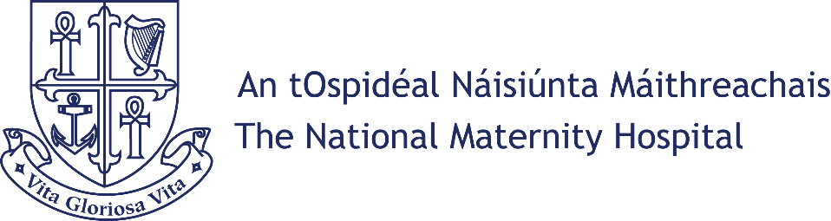

PERSON SPECIFICATION

&

JOB DESCRIPTION

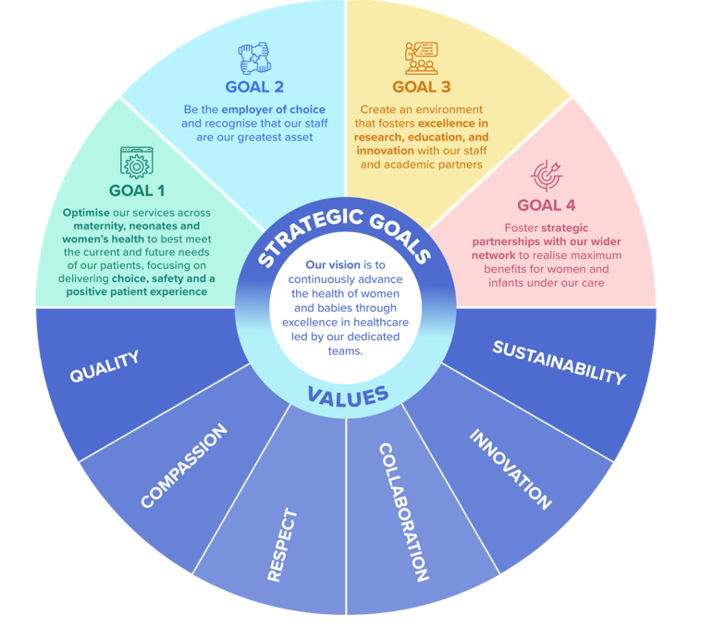

Head of IT / Digital Strategy Lead, Grade VIII


QR code to NMH’s Careers Page

The National Maternity Hospital
About Us, Our Mission and Vision
The Hospital
Established over 130 years ago, The National Maternity Hospital is one of Europe’s largest maternity hospitals and a leading provider of maternity, women’s health and reproductive care.
Our expert multidisciplinary team is dedicated to providing the highest standard of care to women and babies, through a range of services including maternity, women’s health and neonatology. Over the years subspecialties have expanded to include care for women and babies in fetal medicine, maternal medicine, anaesthetic care, perinatal genetics, perinatal mental health, bereavement care, pathology and radiology. The exciting development of The National Maternity Hospital on the St Vincents University Hospital campus is a priority project for NMH. The new NMH will care for women and infants in a modern state of the art facility, future proofing maternity services for decades to come.
Our women’s health services have also expanded significantly and our gynaecology team treats over 10,000 outpatients annually. Our colposcopy service funded by the National Cancer Screening Service is one of the largest units in Europe. We provide specialist services in urogynaecology, gynaecological cancer, complex menopause care, paediatric adolescent gynaecology, pain management, fertility and transgender care.

The Neonatal Intensive Care Unit is a national tertiary referral centre for care of very premature babies and sick infants, with expertise in all advanced therapies such as neonatal therapeutic hypothermia. The Hospital is also contributing to the National Neonatal Transport Programme which offers a national 24-hour service for the nineteen maternity units in Ireland.

The NMH established a community midwifery service in 1998, offering domino birth, early transfer home programmes and homebirth. This service covers Dublin and North Wicklow and continues to be the busiest community midwifery service in Ireland. Over the decades, the hospital has built up an international reputation for undergraduate and postgraduate training and education for the multidisciplinary team of healthcare providers in all related specialties. Staff are also able to avail of extensive professional development which is facilitated in association with our education providers including University College Dublin and the Royal College of Surgeons of Ireland.

Mission Statement
We are the national centre of clinical excellence in maternal, neonatal and gynaecological health. Our mission as leaders in women’s healthcare is to deliver the highest quality of safe, evidence-based care. We are committed to providing choice, listening to and learning from our patients’ experiences. Through excellence and innovation in research and education, we drive the advancement of women and babies’ healthcare in Ireland. Our team is our greatest asset, and we are dedicated to investing in and supporting our people.
Vision
To continuously advance the health of women and babies through excellence in healthcare led by our dedicated teams.

VALUES; Quality, Compassion, Respect, Collaboration, Innovation, Sustainability

“Delivering the future”

Why Work at the NMH?
Staff Benefits Include
 | FINANCIAL :  - Generous statutory defined benefit Pension scheme (including for monthly AVCs)  - Paid sick leave  - Fully Paid Maternity and Paternity Leave  - Employee Discounts (through staff app & WRKIT app)  - Subsidised Staff Restaurant with access to a hot meal Mon – Sun  - Access to Health Service Staff Credit Union  - Financial Planning advice and support (through our EAP service and Pension team)  - Access to Subsidised Parking  - Death in Service Payment
 | EDUCATIONAL :  - Access to co-funding for relevant courses  - Access to paid study leave  - NMH Staff App  - Access to The NMH’s eLearning Hub & App
 | WELLBEING :  - Social Committee  - The NMH are in partnership with WRKIT who offer a number of wellbeing supports  - Drop in clinics with our Occupational Health team  - Employee Assistance Programme  - Long service recognition (5 extra days annual leave awarded at 25 years)

Job Specification / Terms and Conditions
Purpose of the Post: | This is an exciting opportunity to support the hospital in its preparations for it’s future move to the St Vincent’s Campus. As the owner of the hospitals digital Strategy, you will own and drive the hospital’s digital transformation agenda—turning strategic vision into tangible, hospital-wide operational efficiencies and embedding a forward-thinking digital culture. Through Leading the development and implementation of the ICT strategy for the National Maternity Hospital. This role will also include:  - Aligning ICT initiatives with NMH Digital Transformation and Sláintecare priorities.  - Provide expert advice to senior management on ICT capabilities, risks, and opportunities.  - Represent the ICT function at relevant forums  - Leading a team of technical specialists to providing niche technical solutions, while also providing them with the autonomy, resources, and strategic direction to innovate.  - Be a part of and provide Support to the NMH Digital Health Committee,
Job Title: | Head of IT / Digital Strategy Lead
Grade: | Grade VIII –Permanent Post
Department | IT Department
Reports to | Secretary / Manager
Qualifications | At the closing date applicants must:  - A minimum of a third level recognised qualification up to and including degree level in Computer Science, Information Technology or a related discipline i.e. NSQ Level 8 or equivalent.  - At least 5 years experience leading ICT teams or equivalent in a complex, high-stakes environment.  Desirable  - Relevant industry certifications (e.g. MCSA; CCNA/CCNP).  - hold or be willing to complete a Relevant Management course (e.g. supervision training/leadership etc.)  - Knowledge of NIS1 and NIS2 as NMH has been designated as an OES (Operator of Essential Services) by the NCSC.
Terms & Conditions | Tenure: This is a Full Time permanent contract of employment.  Remuneration: Remuneration is in accordance with salary scales approved by the Department of Health / Health Service Executive. The salary scale for this post currently ranges from €83,912 - €101,207 gross per annum.  Assimilation onto the scale is based on relevant work experience and in accordance with circular 17/0213 for existing permanent employees. Payment is made on a monthly/fortnightly basis by credit transfer.  Hours:  35 hours per week, exclusive of unpaid rest breaks.  Annual Leave:  30 working day per annum.  Superannuation/Spouses & Children’s Contributory Pension Schemes:  All employees must join the Superannuation Scheme. An explanatory booklet on the Superannuation Scheme you are aligned to is attached. If you require further details on the scheme please contact the Superannuation Officer, Human Resources on ext. 3360.  Retirement Age:  Persons who entered the Public Service before the 1st April 2004 must retire at the age of 65 years and are eligible for their pension entitlements from the age of 60 onwards. Persons who entered the Public Service on or after the 1st April 2004 will be eligible for their pension entitlements from the age of 65 onwards. Persons entering the Public Service from 1st January 2013, i.e. New Entrants, must retire at the age of 70 and are eligible for their pension entitlements from the age of 66 onwards.  Health:  A candidate for and any person holding the office must be fully competent and capable of undertaking the duties attached to the office and be in a state of health such as would indicate a reasonable prospect of ability to render regular and efficient service.  Garda Vetting:  Satisfactory Garda (Police) vetting is a condition of  employment for this position. It is expected, that you fully disclosed all  information pertaining to any convictions recorded against you in the  Republic of Ireland or elsewhere, or a statement of all convictions and/or  prosecutions, successful or not, pending or complete, in the State or  elsewhere as the case may be. Failure to do so will result in instant dismissal.
Essential Skills | - Be accountable for the competence required to deliver a professional service.  - Extensive awareness of the current professional issues.  - Demonstrate commitment to continuing professional development and a clear commitment to those they supervise supervision process.  - Demonstrate sufficient communication skills (verbal & written) to effectively carry out the duties and responsibilities of the role.  - Demonstrate sufficient clinical knowledge and evidence based practice to carry out the duties and responsibilities of the role.  - Be able to engage with the various Clinical Management teams by supporting and being part of the many innovative clinical initiatives.  - Demonstrate an ability to apply knowledge to best practice.  - Demonstrate the ability to plan and deliver care in an effective and resourceful manner within a model of person-centred care.  - Demonstrate an ability to understand and support the NMH Digital Transformation ambitions and a willingness to work with the various NMH Digital Health initiatives.  - Demonstrate an understanding of, and be fully aligned with the continuous evolvement of “smart” hospital technology and infrastructure.  - Demonstrate an ability to manage and develop self and others in a busy working environment.  - Demonstrate the ability to effectively evaluate information and make appropriate decisions.  - Demonstrate a commitment to ensuring high standards and strive for a user centred service.  - Display effective interpersonal skills including the ability to collaborate with colleagues, families, carers, etc.  - Display an awareness and appreciation for the role of AI and smart healthcare technology / solutions in the NMH digital roadmap.  - Demonstrate effective leadership and team skills.  - Display awareness and appreciation of the service users and the ability to empathise with and treat others with dignity and respect  - Demonstrate flexibility and openness to change.  - Demonstrate a commitment to continuing professional development.  - Willingness to develop IT skills relevant to the role.
Responsibilities & Accountabilities  (in no particular order of priority) | Technical Skills & Operational Skills  - Strong understanding of enterprise IT infrastructure, networks, cybersecurity, clinical systems and “smart” hospital technology solutions and infrastructure  - Be knowledgeable of, and fully aligned with, the developments in, and the shape of, the future Healthcare /Clinical Digital Landscape.  - Knowledge of national eHealth standards, interoperability frameworks, and HSE digital transformation initiatives.  - Ability to oversee system architecture, data governance, and ICT service continuity.  - Skilled in vendor management, procurement processes, and public-sector compliance.  - Proficiency in IT risk management, incident response, and business continuity planning.  - Oversee day-to-day ICT operations, ensuring reliable, secure, and high-quality service delivery.  - Manage ICT service, infrastructure, teams, and application support functions.  - Ensure timely resolution of ICT incidents, outages, and escalations.  - Maintain robust disaster recovery and business continuity arrangements.  - Act as a key point of accountability for ICT security within the organisation.  - Implement and monitor cybersecurity controls, threat-mitigation measures, and compliance frameworks.  - Support Data Protection Officers with audits, DPIAs, and incident investigations as required.  - Ensure all calls to the IT Helpdesk are dealt with in a professional and timely manner through the efficient management of the tools and resources available.  - Support the resolution of day-to-day operational issues within the department.  - Support the planning, coordination and implementation of major changes to the hospital’s IT infrastructure.  - Act as the technical lead on various clinical projects as they arise, engaging with both internal staff and HSE project managers.  - Put in place and update documented procedures to ensure the smooth day-to-day running of the IT Department.  - Liaise, on behalf of the hospital, with hardware and software vendors for the purchase, delivery and on-going support of various systems.  - Proactively seek solutions in areas where IT input could improve current hospital practices.  - Review and assess proven and emerging technologies to determine their suitability for use at the hospital.  - Represent the IT Department at internal and external meetings when required.  - Undertake any other duties and projects as deemed appropriate to the post. Please note that the duties of this post may change over time.  Governance & Compliance Skills  - Deep understanding of the GDPR, data protection, and information security obligations as apply to IT infrastructures.  - Familiarity with HSE governance structures, reporting lines, and audit requirements.  - Ability to develop and enforce ICT policies, standards, and procedures.  - Competence in managing ICT elements of HIQA compliance and other regulatory frameworks.  - Liaise with clinical leads, administrative managers, and national HSE ICT teams.  - Manage relationships with external vendors, service providers, and project partners.  - Oversee procurement of ICT equipment, software, and services in line with public-sector rules.  - Lead ICT projects from initiation to delivery, ensuring alignment with organisational priorities.  - Support digital-health initiatives such as EHR systems, telehealth, and clinical applications.  - Promote change-management practices to ensure smooth adoption of new technologies  Leadership & Management Skills  - Strategic planning and the ability to translate organisational goals into ICT roadmaps.  - Experience leading multidisciplinary ICT teams in a complex, high-stakes environment.  - Strong decision-making skills with the ability to prioritise under pressure.  - Excellent communication skills for engaging clinical, administrative, and executive stakeholders.  - Budget management, cost-control, and resource allocation expertise.  - Mandatory training and completion of annual performance review cycle.  - Be responsible for providing (either directly or by delegation) development to staff members within the Department;  - Provide line management supervision to assigned staff.  - Manage and co-ordinate service delivery in their area of responsibility.  - Assign duties and responsibilities as appropriate to ensure effective service delivery.  - Ensure the maintenance of appropriate records and statistics in accordance with HSE requirements and local guidelines, Freedom of Information Act, Data Protection Acts and other relevant legislation.  - Provide service reports / data as required.  - Contribute to the development and implementation of information sharing protocols, audit systems, referral pathways and integrated care arrangements.  - Actively participate in the development and continuing improvement initiatives of the information technology department.  - Contribute to policy development, performance monitoring, business / service planning and budgetary control within the department.  - Maintain an awareness of HR policies and procedures / engage in recruitment processes and other HR functions as required.  - Assist in ensuring that the service makes the most efficient and effective use of developments in IT.  - Maintain professional standards with regard to service user and data confidentiality.  - Keep up to date with organisational developments within the Irish Health Service.  - The above Job Specification is not intended to be a comprehensive list of all duties involved and consequently, the post holder may be required to perform other duties as appropriate to the post which may be assigned to them from the Secretary / Manager from time to time and to contribute to the ongoing development of the post.
POLICIES AND PROCEEDURES: | For a full list of all the Hospitals Policies and Procedures please refer to q-pulse. In particular, those as outlined within the Contract of Employment which you are required to familiarise and comply with, during the course of your employment.  Health & Safety:  Comply with and contribute to the development of policies, procedures and safe professional practice and adhere to relevant legislation, regulations and standards and ensure their staff compliance.  Have a working knowledge of HIQA or any Standards as they apply to the role for example, Standards for Healthcare, National Standards for the Prevention and Control of Healthcare Associated Infections, Hygiene Standards etc.  Quality:  To ensure the provision of the highest possible quality of service to our patients, all employees at the National Maternity Hospital have a responsibility to ensure adherence to and participation in internal and external quality control and assurance programmes on an ongoing basis.  Healthcare Associated Infections (HCAIs):  In order to reduce the risk of HCAIs, compliance with Infection Prevention and Control policies and the attendance at infection control training, are essential for all staff members. It is paramount that each staff member practice good hand hygiene techniques. Staff members have a responsibility to report any obstacles to maintaining high standards of Infection Control and hand hygiene to their line manager or Infection Control Team  Reminder on Confidentiality:  In the course of his / her employment, the person appointed may have access to or hear information concerning the medical or personal affairs of patients or staff or other health service business. Such records or information are strictly confidential and unless acting on instructions of an authorised officer on no account must information be divulged or discussed except in the performance of normal duty. In addition records must never be left in such a manner that unauthorised persons can obtain access to them and must be kept in safe custody/destroyed in accordance with policy when no longer required.
Note: This job description is an outline of current broad areas of responsibility and accountability and should not be regarded as a comprehensive listing. As the role develops in the Hospital this job description may be reviewed in light of possible new structures and/or changing needs of the Hospital.

