
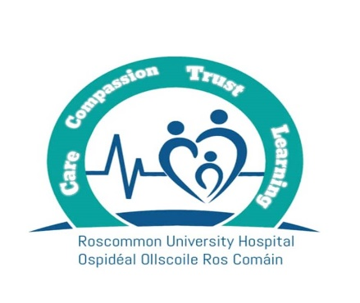
Transition Year (TY) Students Accessing Work Experience in a Health Care Setting

Job Title | Work Experience for Transition Year (TY) Students.
Working Week | The student will undertake work experience for 1 week (Monday to Friday – 35 hours).
Closing Date | 12 noon on Friday, 25th September 2026.
Location of Post | All areas of the Hospital. The student can select their preferred location in the application form.
Purpose of the Post | We are currently on the lookout for transition year students who want to gain exceptionally experience in the health care sector between November 2026 and May 2027.  Please refer to the printable Transition Year Work Experience Brochure for more information.
Informal Enquiries | We welcome enquiries about the role.  Laura Beirne, Assistant Staff Officer, Human Resources & Medical Workforce Department, Roscommon University Hospital.  Telephone: 090 – 6632351 or Email: HR.RUH@hse.ie
Applications | Applications must be submitted via Rezoomo only. Applications received in any other way will not be accepted. There will be no exceptions made.
Selection Process | If Roscommon University Hospital receive a huge number of application forms, a lottery-based selection process will be applied.
Documentation Required if Successful for the TY Programme | To secure a place, all students must submit:  - A Letter of Recommendation from their school.  - Proof of Indemnity Insurance from their school.  - Garda Vetting Clearance from their school.  - Parental Consent for Student to engage in Work experience from school.  Failure to provide all documentation at least 4 weeks before the placement start date will result in automatic cancellation of the placement.

